#Creating a New database:

Code:

mongod --version

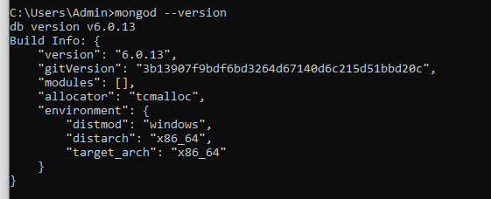

mongosh

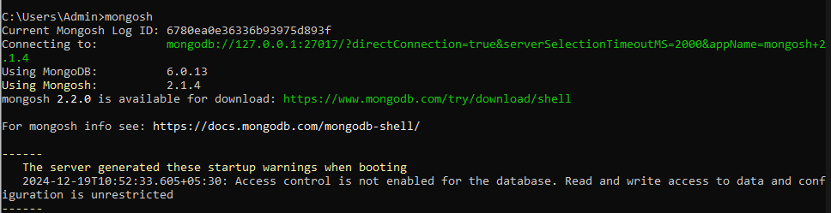

#Create a database name userdb

use userdb;





#Creating a New Collection:

db.createCollection("users")



#Create Operation

1.insertOne():

db.users.insertOne({

name:"Angela",

age:27,

});

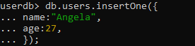

Output:

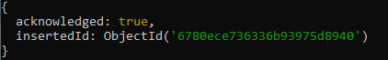

2.insertMany()

db.users.insertMany([ { name:"Angela", age:27, }, { name:"Dwight", age:30, }, {name:"Jim", age:29,}]);



Output:

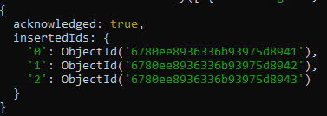

#Read Operations

1.find()

db.users.find()



Output:

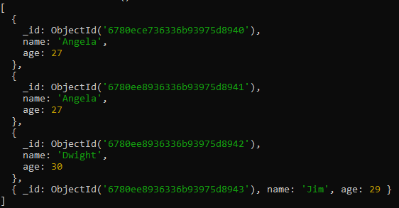

db.users.find({age: {$gt:29}}, {name:1, age:1 })



Output:

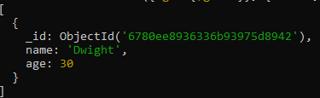

2.findOne()

db.users.findOne({name:"Jim"})

****

Output:



#Update Operations

1.updateOne()

db.users.updateOne({name:"Angela"},{$set:{email:"angela@gmail.com"} })



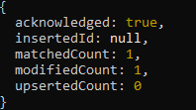

db.users.findOne({name:"Angela"})

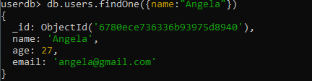

2.updateMany

db.users.updateMany({ age:{$lt: 30}}, {$set: {status:"active"} })

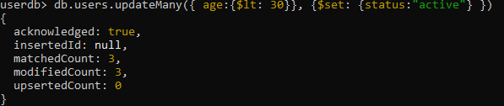

db.users.find()

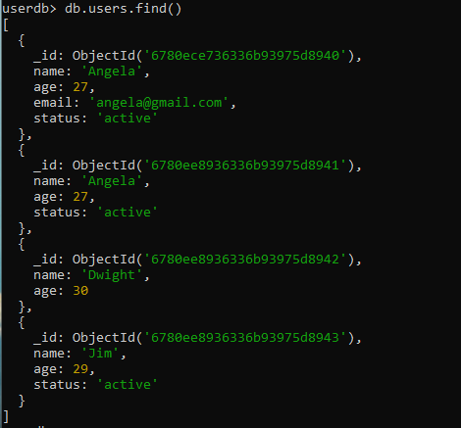

#Delete Operations

1.deleteOne()

db.users.deleteOne({name:"Angela"})



db.users.find()

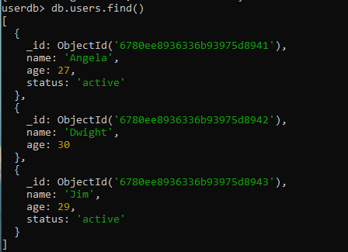

2.deleteMany()

db.users.deleteMany({age:{$lt:30} })



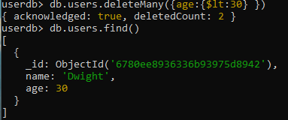

#drop()

db.users.drop()

